**LOCATION RECOMMENDATION FOR A SOUVENIR SHOP**

Cao Thi Nham

March 06, 2020

# INTRODUCTION

## Background

Danang is Vietnam's third largest city, and is one of the most attractive location for tourists in Vietnam. As a citizen of this city, I decided to use Danang in my project.

The city of Danang is about 1,256 square kilometres in size and divided in to 8 districts. From the fact that there are more than 6 million arrivals to this city annually, opening a souvenir shop is potentially successful. From an investor’s view, locations are an important factor to the susccess of the business. In fact, not all of the areas attract tourists equally, therefore I assume that locations that have high visitor density are potential places to do business of selling sourvenirs. However, it is difficult to acquire information that will guide investors in this direction.

## Problem

Data about check-ins of venues in the city may contribute to determining locations that are suitable for the business of souvenir shop.

## Interest

Obviously, investors would be very interested in the map that show potential locations for their business of selling a souvenir shop.

# DATA ACQUISITION & CLEANING

## Data source

To solve problem, I used the following data source:

* Data from Foursquare to get common venues and their numbers of visitors/checkins.

## Data acquisition

To retrieve numbers of visitings of venues in Danang, firstly I used Foursquare API to get popular venues in Danang, and the result is 100 venues with details information as follow.

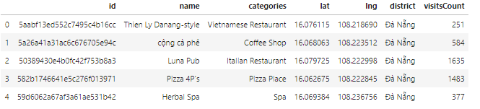

Secondly, I used Foursquare API again to get detail information of each venue, especially visitsCount. And the result as the sample data:



Finally, I used folium python library to visualize the positions of venues on the map.

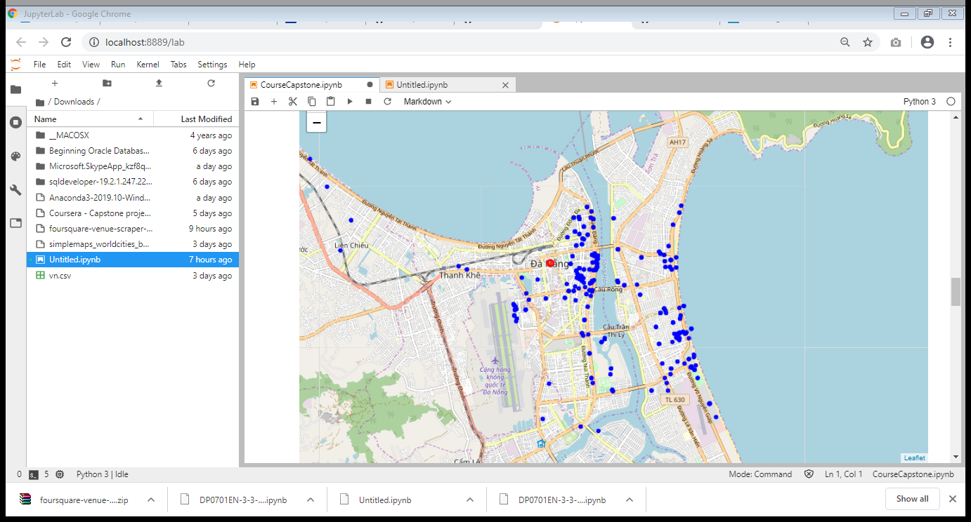

From the map, we can see that venues are quite dense in the center of the city.

# METHODOLOGY

Firstly, I find the best k for k-mean algorithm by using Elbow method.

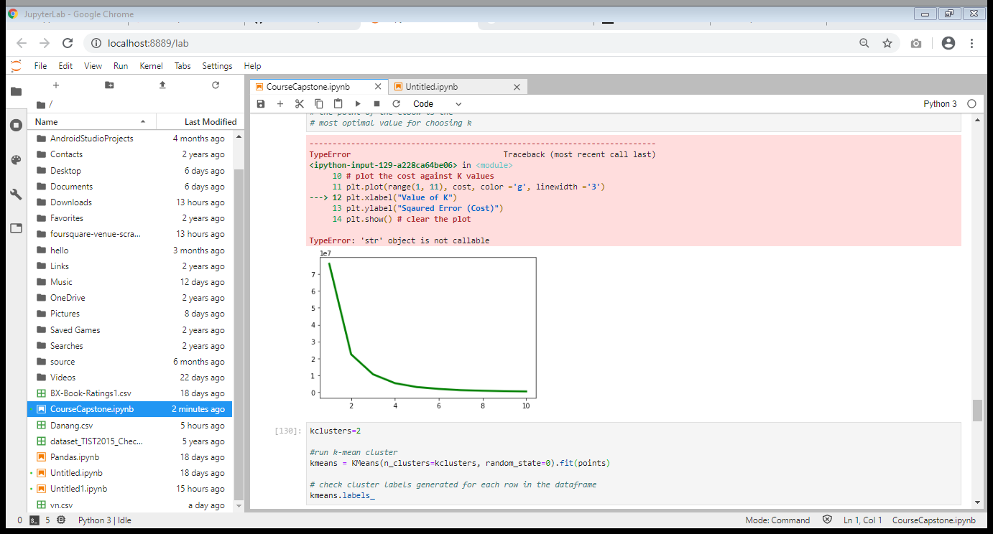

According to line graph, the optimal value for k is 2, thus I segment venues into 2 clusters based on visitsCount.

Next steps, I used k-mean to cluster venues.

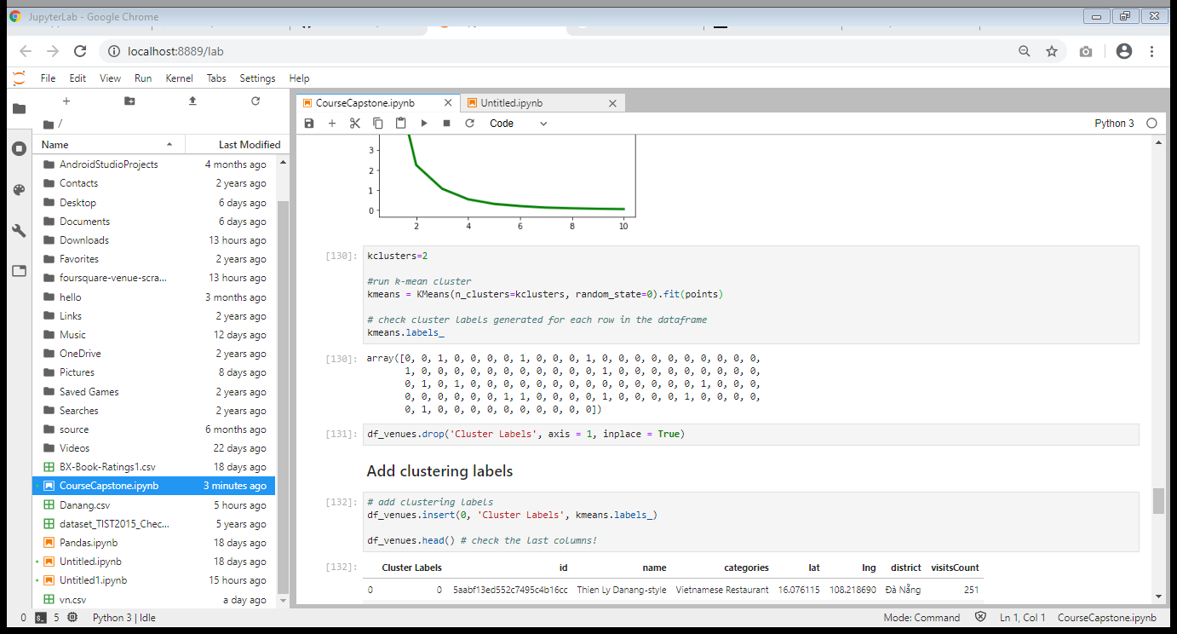

Finally, I visualized the clusters.

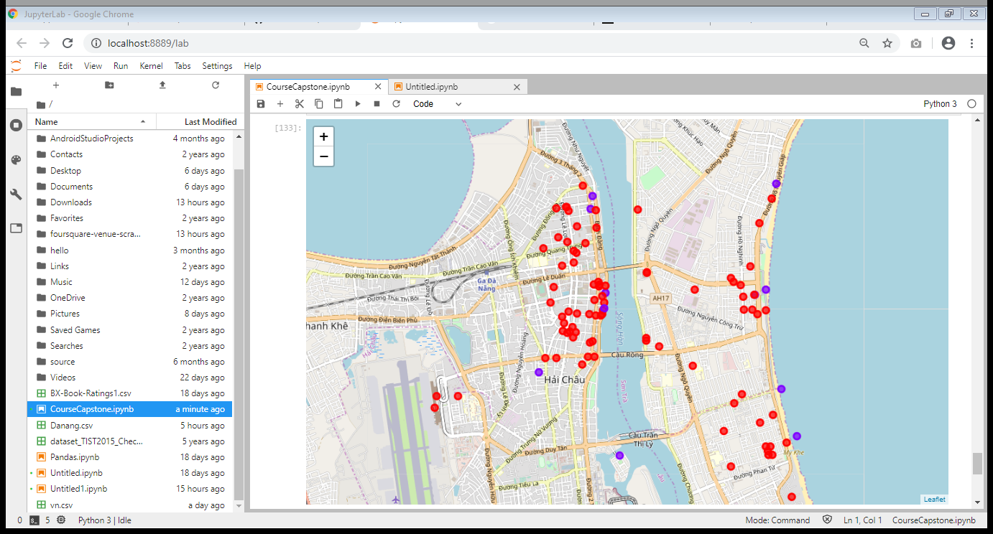

# RESULTS

From the above map, red pots are venues with high numbers of visitors. As I assumed above, the higher visitor density, the more potential to start business with souvenir shop. Consequently, the area between Cầu Rồng brigde and Sông Hàn brigde is potential location.

# CONCLUTION

As I mentioned above, Da Nang is a tourism city in Vietnam. It is very potential to open a souvenir shop to do business and introduce Vietnamese culture. In this project, I retrieved data of popular venues in Da Nang by using Foursquare API and then segmented them by numbers of visitings to find the optimal location to start the business. Based on the map, investors could clearly realize the locations they can start with.